|  |  |  |  |
| --- | --- | --- | --- |
| \\lyng-dc1\StaffShared\Learning Bugs Animals ALL subjects\characters bugs animals\Cyril the Snail - History.jpeg**Lyng Primary School Knowledge Organiser** | | | |
| **History Topic: Roman** | **How did the Roman Empire become so powerful?** | Year 5  *Civilisation and Communication and invention* | Summer |

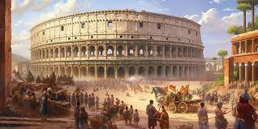

**Background information for parents and teachers**  
The Romans were ancient people who lived in a place called Rome, which is now in Italy. They were great builders, warriors, and rulers who lived over 2,000 years ago. The Roman Empire was huge and covered parts of Europe, Africa, and Asia. They built amazing cities, roads, and bridges that are still used today.

|  |  |
| --- | --- |
| **What Step On and Goldilocks words will I use?** | |
| **Spelling** | **Definition** |
| Caesar | A title used by emperors |
| Dictator | A ruler with total power over a country who uses force. |
| Empire | A group of countries ruled over by a singular emperor |
| Emperor | A sovereign ruler of an empire |
| Mosaic | A picture or pattern produced using small pieces of stone, glass or tile. |
| Citizen | Recognised person of a country |
| Assassination | Murdering someone due to political views |
| Republic | A form of government when people elect their leader. |

|  |  |
| --- | --- |
| **When? (Timeline of key events)** | |
| 753 BC | Roman Empire began |
| 509 BC | Rome became a Republic |
| 449 BC | The Law of the Twelve Tables |
| 218 BC | Hannibal invades Italy |
| 98 BC | The city of Rome expelled non-Roman citizens except slaves |
| 50 BC | Rome introduces the gold coin |
| 45 BC | Julius Caesar became the first dictator of Rome |
| 44 BC | Julius Caesar was killed |
| 27 BC | Roman Empire began to spread under Augustus the first Emperor |
| AD 44 | Rome invaded Britain |

**Hook**

**Make a mosaic**



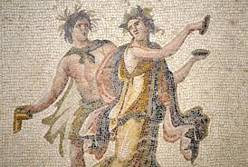

**Great Quotes**

**Augustus Caesar** – “Power is not given, it is taken!”

**Our Storytelling Approach to enhance engagement**

|  |  |  |
| --- | --- | --- |
| **People:**  Julius Caesar | **Place:**  Rome | **Problem:**  How can I expand my empire? |

**Key Facts and Famous Figures**

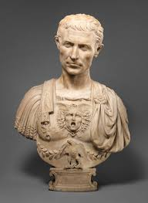

Julius Caesar: A renowned military general and statesman who played a critical role in the demise of the Roman Republic and the rise of the~  
 Roman Empire. He was a brilliant military strategist, a powerful orator, and a skilled politician. Caesar's assassination in 44 BCE marked a  
 pivotal moment in Roman history.

Augustus Caesar (Octavian): The first emperor of Rome, Augustus (originally known as Octavian) was Julius Caesar's adopted son and heir.   
He played a central role in the transformation of the Roman Republic into the Roman Empire and reigned as emperor from 27 BCE until his  
 death in 14 CE. Augustus brought stability and initiated significant reforms that shaped the Empire for centuries.

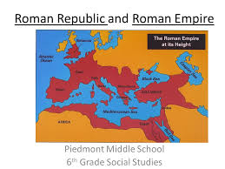Republic and Empire: Rome transitioned from a monarchy to a republic around 509 BCE, with a system of elected officials and a complex   
system of checks and balances. In 27 BCE, the Republic transitioned into the Roman Empire with the rise of Augustus Caesar, marking the  
 beginning of imperial rule.

Expansion: Ancient Rome started as a small city-state but eventually grew to encompass a vast empire stretching from Britain to North Africa  
 and from Spain to the Middle East. Its expansion was marked by military conquests, colonization, and diplomacy.

**Key skills – Sequence of Learning**

How did Rome become and republic?

How did Rome become a powerful empire?

How did Julius Caesar help the Roman empire expand?

What happened after the assassination?

Use

|  |  |  |  |
| --- | --- | --- | --- |
| \\lyng-dc1\StaffShared\Learning Bugs Animals ALL subjects\characters bugs animals\Cyril the Snail - History.jpeg**Lyng Primary School Knowledge Organiser** | | | |
| **History Topic:** | **How did the Roman Empire become so powerful?** | Year 5  *Civilisation and Communication* | Summer |

|  |
| --- |
| What happened to Julius Caesar? |
| Start: |
| End:   |  |  |  | | --- | --- | --- | | How became emperor after Julius Caesar? | **S** | **E** | | 1. Caesar Augustus |  |  | | 1. Emperor Nero |  |  | | 1. Marcus Brutus |  |  |  |  |  |  | | --- | --- | --- | | Which of these are Roman legacies? (More than 1) | **S** | **E** | | Roads |  |  | | Baths |  |  | | Central Heating |  |  | | Aqueducts |  |  |  |  |  | | --- | --- | | Why did the Romans invade Britain? | | | Start | End | |

|  |  |  |
| --- | --- | --- |
| Who was in the first Triumvirate? | **S** | **E** |
| 1. Julius Caesar |  |  |
| 1. Pompey the Great |  |  |
| 1. Spartacus |  |  |
| 1. Marcus Licinius Crassus |  |  |



**Roman Quiz**

|  |  |  |
| --- | --- | --- |
| When did the Roman Empire begin? | **S** | **E** |
| a) AD 27 |  |  |
| b) 44 BC |  |  |
| c) 27 BC |  |  |
| d)AD 44 |  |  |

|  |  |  |
| --- | --- | --- |
| How long was Julius Caesar in power? | **S** | **E** |
| a) 2 years |  |  |
| b) 10 years |  |  |
| c) 1 year |  |  |
| d) 5 years |  |  |